

Web Technologies

Final Group Project

University Football Team

Students: Moldir Takhtanova, Nurbek Abeuov, Maksut Malik, Alima Koishibekova

Group: TS-2003, TS-2004

Tutor: Aldiyar Salkenov

Nur-Sultan, 2021

# **Overview**

**Team Responsibilities:**

* Moldir – working with the server that is, the js code and presentation for project.
* Nurbek – documentation and slick css code.
* Maksut – html parts of website
* Alima – style css code.

**Communication strategy:**

* Verbal: face to face, telegram chats
* Visual: schedule of the action plan
* Brainstorming every day at the end of the meeting

**Motivation**:

The project is needed to count the goals of our university team "AITU Football". Now many students cannot attend the match in order to support their team. But thanks to this site, they can find out the score of the game and the players who scored a goal. Thus saving time.

**High-level project scope:**

The website was created from scratch using bootstrap components and css blanks, and blanks for animation.

**Target audience/market**:

The project is mainly focused on the university, the university football team, student fans.

# **Project goals and team interests**

**Project goals:**

* To write a fully functional website that is easy for users to use and verify any information.
* Reduce time consumption.
* Attracting more people to the love of football.

**Team interests:**

* Analyze the work with the server and the background.
* Improve teamwork skills
* Improve communication skills by working with students from other groups
* Understand the clear operation of the principles of working with servers and their configuration

# **Phases**

* Phase 1 – A regular website made of HTML and CSS (already done)
* Phase 2 – Animation installations and connection with links (done)
* Phase 3 – Install a database for which you will need PHP to connect (need to do)
* Phase 4 – Create a more global server server using Javascript and connect (need to do)
* Phase 5 – Make a chatbot for help and for answers to frequently asked questions.

# **Content structure**

**Site map**

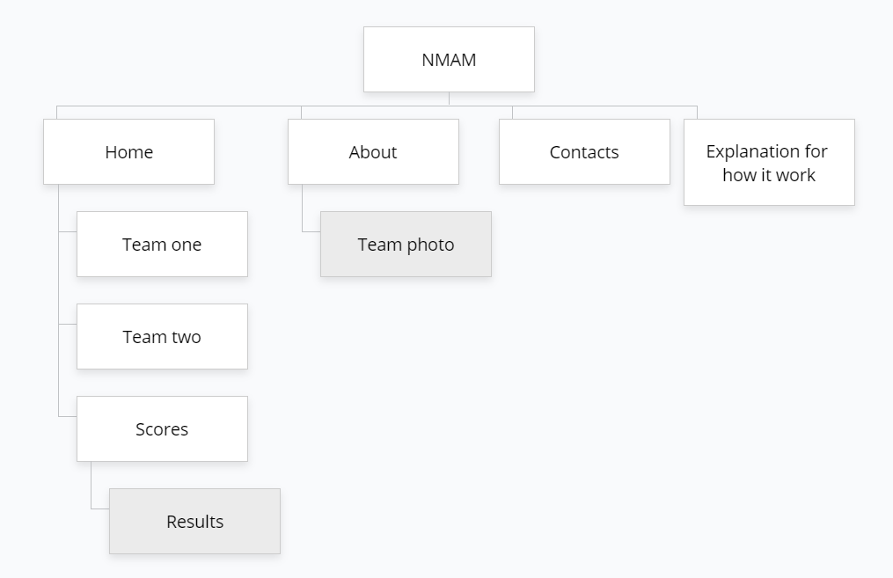

**Content types:**

* News
* Sports
* Entertainment
* Informational (contact us, reserve)
* Video

**Design:**

* Reference links
* Fade in right
* Images
* Logotype
* Color
* Fonts
* Animation
* Spacing

**Functionality:**

Our website counts the goals scored. Let's now look at the order in which everything needs to be done. To begin with, in the "home" tab, we can see that there are empty fields in "Team one" and "Team two", we have to record 11 players each, if there are fewer, then our code will not work. After filling in, we go to "Scores", there we have to record how many goals each team scored, but there can only be a maximum of 7 goals when they arrive, if there is more, it will give an error. As we fill in everything, you will be able to see the result in the form of "Team one won".

**Accessibility**

* Heading – helps the user navigate the site.
* Color – a very simple color scheme design, but not boring. Specially selected color that catches the eye but does not irritate. For colorblind people, this site is not harmful.
* Help form – this site is quite difficult to understand without instructions, so we added the "How it works" part specifically for this problem. But if this did not help the user, then you can use the contacts that are mentioned at the end of the site.

**Deadlines**

Plan – 13.11.2021

HTML – 15.11.2021 14:00

CSS – 15.11.2021 23:59

JS – 17.11.2021 20:00

Connect with app.js – 17.11.2021 23:59

Documentation – 20.11.2021 23:59

Presentation – 21.11.2021 16:30

# **Summary**

In conclusion, we can say that we have achieved our goal. This job was difficult, but working in a group made a lot easier. This is a good experience of working with students from another group. Together we improved in writing JavaScript, as this was one of the most difficult parts. Also, one of the most difficult things was CS, in this part we spent a lot of nerves and strength. We think that we have successfully completed the task.